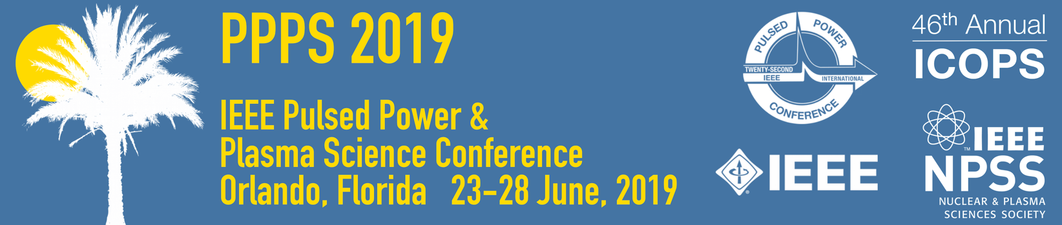

Application for NPSS Child Care Assistance

The Nuclear & Plasma Sciences Society is offering child care reimbursement of up to $400 per family as a Pilot Program to assist conference attendees who incur additional childcare expenses by attending an NPSS conference. Expenses must be documented by receipts. Limited funds are available, and preference will be given to applicants in the early stages of their careers who are IEEE NPSS members. Up to five candidates will be selected per conference.

Applications must be received by March 9, 2019 to be considered by the conference committee. Applicants will be notified by April 9, 2019 about the decision regarding their application.

Name: _________________________________________
Institution: _________________________________________
Phone: _________________________________________
Email: _________________________________________
IEEE member number: _________________________________________
NPSS member? _________________________________________

Career Status (please check one):
____ Post Doc _____ Graduate Student
____ Undergraduate student _____ Early-career (pre-tenure)
____ other (please explain)
____________________________________________________________________________
____________________________________________________________________________

Please provide a short description detailing your needs (number of children, type of care needed, number of hours needed, and estimated cost). Please be as specific as possible.
____________________________________________________________________________
____________________________________________________________________________
____________________________________________________________________________
____________________________________________________________________________
____________________________________________________________________________
____________________________________________________________________________
____________________________________________________________________________
____________________________________________________________________________

Return completed nomination form no later than March 9, 2019 by email to: treasurer@ppps2019.org
Expense Documentation for NPSS Child Care Assistance

To receive reimbursement for childcare expenses documented by receipts, the conference finance chair/Treasurer must receive the completed IEEE Expense Report form within two weeks of the completion of the conference.

On the IEEE Expense Report form, please fill in:
Name
Address
For Period Ending
IEEE Member number (if applicable)

Enter your childcare expenses as:
Mileage (if applicable)
Other

Please include receipts and/or other documentation detailing your childcare expenses.

Return completed form no later than 12 July, 2019, by email to:
treasurer@ppps2019.org

